2. 6 4. 3 7. 0

11.

#pragma warning(disable:4996)

#include<stdio.h>

int main() {

char ifrun = 0 ;

int year, month;

printf("Please inout the year and the month.\n");

scanf("%d%d", &year, &month);

if (year % 100 && year % 4 == 0 || year % 400 == 0) ifrun = 1;

switch (month) {

case 1:

case 3:

case 5:

case 7:

case 8:

case 10:

case 12:

printf("%d", 31);

break;

case 4:

case 6:

case 9:

case 11:

printf("%d", 30);

break;

case 2:

printf("%d", ifrun ? 29 : 28);

break;

default:

printf("error");

break;

}

return 0;

}

}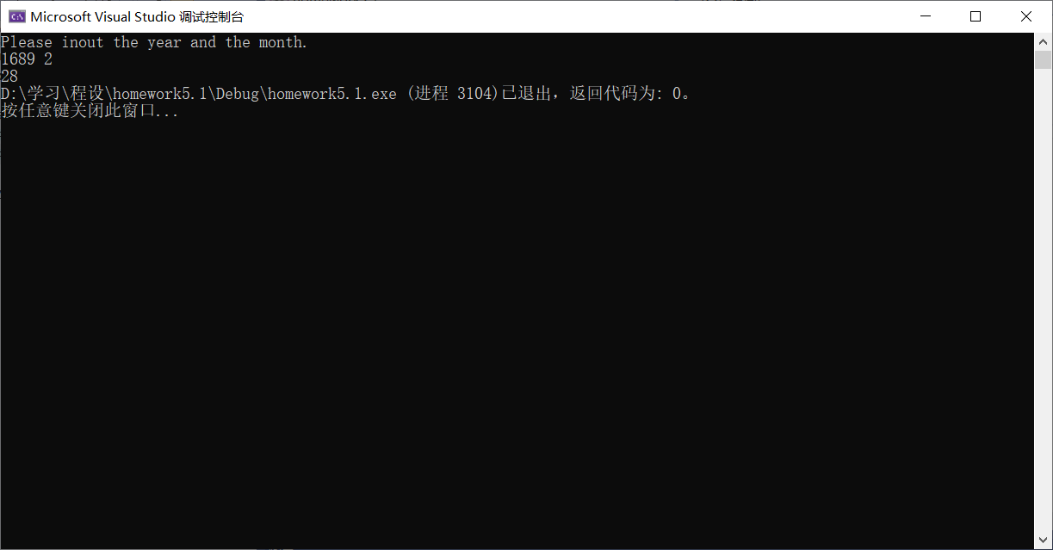

14.

#pragma warning(disable:4996)

#include<stdio.h>

#include<math.h>

int main() {

double x , fx;

scanf("%lf", &x);

fx = x \* x \* x \* x - 3 \* x \* x - 8 \* x - 30;

if (fabs(fx) < 1e-6) printf("Y");

else printf("N");

return 0;

}

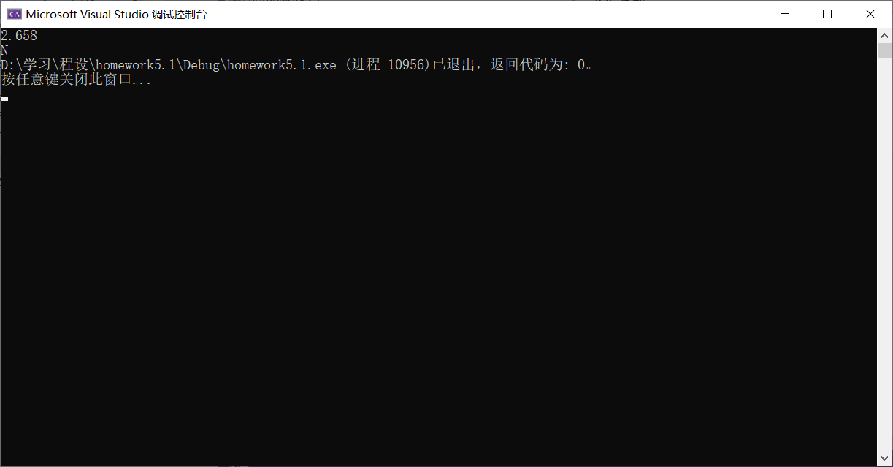

19.

#pragma warning(disable:4996)

#include<stdio.h>

void Sort(int\* a, int Size) {

if (Size <= 1) return;

for (int i = 0; i < Size - 1; ++i) {

if (a[i] > a[i + 1]) {

int tmp = a[i];

a[i] = a[i + 1];

a[i + 1] = tmp;

}

}

Sort(a, Size - 1);

}

int main() {

int fourdig, a[4], max[4] = {-1,-1,-1,-1};

printf("Please input an integer which has 4 dogits.\n");

scanf("%d", &fourdig);

if (fourdig < 1000 || fourdig >9999) {

printf("ERROR");

return 0;

}

a[0]= fourdig % 10;

a[1]= fourdig /10 % 10;

a[2]= fourdig / 100 % 10;

a[3]= fourdig / 1000 % 10;

printf("The reserved number is:%d%d%d%d\n", a[0], a[1], a[2], a[3]);

Sort(a, 4);

printf("The maximum number is:%d%d%d%d\n", a[3], a[2], a[1], a[0]);

printf("The minimum number is:%d%d%d%d\n", a[0], a[1], a[2], a[3]);

return 0;

}

